**Point of care circulating cathodic antigen accuracy in the diagnosis of schistosome infection: systematic review and meta-analysis**

Danso-Appiah Aa*, Jonathan Mintonb, Daniel Boamahc, Joseph Otchered, Richard H Asmahe, Mark Rodgersf, Paolo Eusebig,h, Kwabena M Bosompemd, Sake J De Vlasi

## a Department of Epidemiology and Disease Control, School of Public Health, University of Ghana, Legon, Ghana

## b School of Social and Political Sciences, Adam Smith Building, University of Glasgow, Glasgow, Scotland

## c Department of Microbiology, Centre for Plant Medicine Research, Box 73, Mampong, Ghana

## d Department of Parasitology, Noguchi Memorial Institute for Medical Research, College of Health Sciences, University of Ghana, Legon, Ghana

## e School of Biomedical and Allied Health Sciences, College of Health Sciences, University of Ghana, Legon, Ghana

## f Centre for Reviews and Dissemination, University of York, York, UK

g Department of Epidemiology, Regional Health Authority of Umbria, Perugia, Italy

h Neurologic Clinic, Department of Medicine, University of Perugia, Perugia, Italy

## i Department of Public Health, Erasmus MC, University Medical Center Rotterdam, The Netherlands

## *Dr Anthony Danso-Appiah [tdappiah@yahoo.co.uk](mailto:tdappiah@yahoo.co.uk); [adanso-appiah@ug.edu.gh](mailto:adanso-appiah@ug.edu.gh)

## ABSTRACT

## Objective We assessed diagnostic accuracy of POC-CCA test for schistosome infections using Kato-Katz thick smear (for *S. mansoni* and *S. japonicum*) or 10 mL urine filtration (for *S. haematobium*) as reference standard.

## .

## Methods We searched MEDLINE, EMBASE and LILACS from inception to 30th September 2014 (and updated to 30th September 2015) with no language restrictions, and the Cochrane Library 2015, reference lists of articles and grey literature. We contacted experts for additional or unpublished studies Twenty-eight studies published between 1994 and September 2015 met the inclusion criteria, analysed and presented as sensitivity and specificity with their 95 % CIs and HSROC curves. LCBM was fitted to capture the between-study variability in sensitivity and specificity.

**Findings** One POC-CCA test performed better than one Kato-Katz for detecting *S. mansoni* infection (pooled sensitivity 0.90, 95% CI 0.84 to 0.94 and specificity 0.56, 95% CI 0.54 to 0.61; seven studies) or three Kato-Katz tests (pooled sensitivity 0.85, 95% CI 0.80 to 0.88 and pooled specificity 0.66, 95% CI 0.54 to 0.76; fourteen studies). There is no demonstrable advantage of three CCA tests over one test. Latent Class Analysis identified two classes of POC-CCA. (value here)(value) (2 studies).

## Conclusion The findings show that a single POC-CCA test may be better than single or three Kato-Katz tests for detecting *S. mansoni* infection, but the evidence for *S. haematobium* may be inconclusive as it comes from only two studies

## BACKGROUND

## Schistosomiasis, caused by blood fluke, a group of flat worms that reside in the blood vessels in the human hosts, is commonly found among low income countries in the tropical and sub-tropical regions whose health systems face difficulties to provide basic care at the peripheral level.1 An estimated 800 millon people are at risk of the infection and 207 million have the infection.2-5 A person with schistosomiasis may be re-infected repeatedly even when regular treatment is provided6-7 , necessitating repeated screening in endemic populations. Five species, namely *Schistosoma mansoni*, *S. haematobium*, *S. japonicum*, *S. intercalatum* and *S. mekongi* can infect humans but the three with significant public health impact are *S. mansoni* (common in Africa and some countries in South America including Brazil), *S. haematobium* (mostly endemic in Africa and the Middle East) and *S. japonicum* (mainly found in the People’s Republic of China, Lao and the Philippines).5 *S. mansoni* and *S. japonicum* cause intestinal schistosomiasiswhilst *S. haematobium* causes urogenital schistosomiasis.

The WHO strategy for schistosomiasis control over the years has been active detection of individuals with infection and treatment with praziquantel (PZQ). Mass treatment with no prior diagnosis is usually employed in high endemicity settings. For intestinal schistosomiasis, Kato-Katz thick smear8 is the recommended diagnostic technique because of its assumed sensitivity, ability to classify intensity of infection, ease of use in the field and low cost whereas the standard 10 mL filtration of urine is used for urinary schistosomiasis. Sensitivity of both the Kato-Katz and urine filtration depends on severity of the infection, and in low grade infections, sensitivity may be well below 30%.9-10 For Kato-Katz test for example, several stool specimens collected on different days are required to increase sensitivity.

The prevalence and intensity of infection have fallen significantly in most endemic areas through mass drug administration within the preventive chemotherapy strategy (ref). Undoubtedly, routinely used diagnostic tests such as Kato–Katz thick smear and urine filtration techniques are no longer sensitive. Therefore, sensitive and easy-to-use at low cost diagnostic is a necessity. Detection of *Schistosoma* circulating antigens using specific monoclonal antibodies has been shown promise (ref). High sensitivities in determining active infections have been achieved with assays for detection of the circulating cathodic antigen (CCA) and the circulating anodic antigen (CAA) in serum or urine. Research based on CCA has produced the point-of-care (POC) lateral flow urine cassette assay for diagnosis of schistosome infection (van Dam et al.), which has been validated in several studies (refs). Recent studies in settings in Africa have demonstrated that a market-ready urine-based CCA test is much more sensitive than Kato-Katz technique, even though it appears to suffer the same limitation of low sensitivity for low infection intensity. The CCA assay has been evaluated in different settings across geographic locations and studies have reported sensitivities of around 80% although sensitivity for urinary schistosomiasis is variable.11

There is no study that has systematically and robustly pooled data in a systematic review to provide reliable evidence on the performance of CCA tests although systematic reviews are widely regarded as the best form of evidence to inform public health decisions.12-13 The WHO commissioned this study to test and assess the diagnostic accuracy of the urine-based CCA test in a systematic review and meta-analysis.

This review was conducted with the primary objective to assess diagnostic accuracy of POC-CCA test for the diagnosis of schistosome infections using stool-based Kato-Katz thick smear (for *S. mansoni* and *S. japonicum,*) or standard 10 mL urine filtration (for *S. haematobium*) as reference standard. The secondary objectives were to assess the performance of ELISA for CCA in serum or urine, or other CCA assays and cost of field application of POC-CCA as well as effect of geographic location, age, endemicity and prior treatment on the performance of CCA. The study also compared time required for preparation and application; and patient preference for POC-CCA versus Kato-Katz technique and standard 10 mL urine filtrate method.

**CRITERIA FOR CONSIDERING STUDIES FOR THIS REVIEW**

### Eligibility standard forms based on predefined inclusion criteria were used retrieve, select and assess quality of the studies.

### Types of studies

Every study that compared CCA test with a reference standard (Kato-Katz or urine filtration, or both) for the diagnosis of schistosome infection; where precontrol infection status of the participants was not known; and tests were performed in the same participants, were eligible for inclusion.

### Types of participants

Individuals diagnosed microscopically for the presence of schistosome eggs in their stool (for intestinal schistosomiasis due to *S. mansoni* and *S. japonicum*) using the Kato-Katz technique as reference standard8 or in their urine using the standard 10 mL urine filtration method (for urinary schistosomiasis due to *S. haematobium*).

**Diagnostic thresholds**

We used the commonly applied intensity thresholds based on WHO classification for interpreting data. POC-CCA is classified as trace as negative (-), trace as positive (tr), single positive (+), double positive (++) and triple positive (+++); Kato-Katz as light infection (< 100 EPG), moderate infection (100-399 EPG) and heavy infection (≥ 400 EPG); and the standard 10 mL urine filtration test as light infection (≤ 50 eggs/10mL of urine) and heavy infection (> 50 eggs/10mL of urine).

## REVIEW METHODS

## Search methods for identification of studies

We searched MEDLINE, EMBASE and LILACS from inception to 30th September 2014 (and updated the search to 30th September 2015)using various search terms with no language restriction. We also searched BIOSIS, Web of Science, Google Scholar, Rapid Medical Diagnostics database: <http://www.rapid-diagnostics.com/publications.html>, African Journals Online, Cochrane Infectious Diseases Group Specialized Register, CENTRAL (The Cochrane Library 2014) and mRCT. As accuracy studies present with lack of suitable methodological search filters, we maximised sensitivity of our search by using free texts based on the index test and target condition. We also hand-checked the reference lists of relevant articles and books, and contacted experts for additional or unpublished studies.

**Selection of studies**

One author (ADA) searched the literature and retrieved studies using the aforementioned search strategy. Two authors (ADA, JO) screened the results to identify potentially relevant studies. Full study reports were obtained and assessed for eligibility for inclusion in the review using eligibility form based on the predefined inclusion criteria. Twenty-eight studies published between 1994 and September 2015 met the inclusion criteria. Any discrepancies were resolved through discussion between the authors.

**Data extraction and management**

Study characteristics such as citation, country and year study was conducted, study design and methods were recorded on standard forms (Table 1). Information on diagnostic criteria of both the index test (CCA) and reference standard was also extracted. The number of urine samples tested and threshold classification of POC-CCA were extracted. For Kato-Katz technique, data extracted included number of stool samples per participants, number of slides and volume of stool examined as well as how intensity of infection was classified (low, moderate and high). For urine specimens, information about time of day samples were collected, number of urine specimens, and intensity categorization (low and high) were extracted. We also extracted epidemiological and demographic data including endemicity status, region where the study was conducted, participants’ prior treatment status, target population (preschool-aged children, school-aged children, adults, whole population or representative sub-sample), sex and age distribution and study size. Where necessary, we extracted information on cost, level of training and experience of technician and whether diagnostic technique was delivered in the field or laboratory setting.

We extracted data on ‘true positives’ (TP) defined as individuals with infection who tested positive, ‘false positives’ (FP) as individuals without infection who tested positive, ‘true negatives’ (TN) as those who did not have infection and tested negative, and ‘false negatives’ (FN) as individuals with infection but tested negative. These were needed to populate the 2 x 2 tables. Authors of primary studies were contacted for unclear or insufficient data. Where possible, we obtained raw data from primary study authors for the calculation of values needed to populate the 2 x 2 contingency table. For studies that provided categorical data based on intensity of infection classification or thresholds, we extracted numbers of index test positive and negative participants using the thresholds defined in the review protocol. If two or more communities were involved in the study, data were extracted for each community, with a link to the parent study. Two authors (ADA and DB) extracted data using a pre-tested data extraction form and cross-checked for any errors. Disagreements were resolved through discussion.

**Data synthesis**

Data were analysed and presented as sensitivity, specificity and false positive rate, with their 95 % confidence intervals (CI) for frequentist analyses, and 95% credible intervals (CrI) for Bayesian analyses. The meta-analyses were performed using the bivariate model specified inReitsma14, using the Mada package in the R programming environment. A continuity correction of 0.5 was added to all cell values. The function fits the bivariate model described by Reitsma14 that Habord15showed to be equivalent to the Hierarchical Summary Receiver Operating Characteristics (HSROC) by Rutter.16. We specified the model as a linear mixed model with known variances of the random effects, similar to the computational approach by Reitsma14. Variance components are estimated by restricted maximum likelihood (REML). In addition meta-regression is possible and the use of other transformations than the logit, using the approach of Doebler17. The bivariate meta-regression was conducted using random effects approach incorporating the amount of correlation between sensitivity and specificity across studies. A p-value below 0.05 was used to test statistical significance. In order to remove the need to adjust for confounders, the analysis was restricted to studies that evaluated both index and reference standard tests in the same patients. Sub-group effects were investigated by stratifying the analyses by age (preschool children and infants, school- aged children and adults), sensitivity of reference standard and background endemicity measured by prevalence of the infection: low, moderate and high (for intestinal schistosomiasis) and low and high (for urinary schistosomiasis).

**Assessment of heterogeneity and sub-group analysis**

We assessed heterogeneity by inspecting the forest plots for overlapping CIs and outlying data; using the Chi-squared test with a p-value < 0.10 to indicate statistically significant heterogeneity based on commonly accepted DerSimonian & Laird test that uses a more sensitive threshold of p < 0.10 (DerSimonian 1986)18 The Cochrane collaboration recommends the use of p-value < 0.10 in statistical testing of heterogeneity in accuracy tests (Bossuyt)19 Therefore, we followed this convention, by defining heterogeneity as significant when p < 0.10 rather than the conventional level of p-value < 0.05. Methodological and clinical differences such as patient populations (preschool-aged children, school children, or adults), tests type, study design type and robustness of conduct of the study were considered in addition to the aforementioned statistical measures. When significant heterogeneity was detected, we carried out subgroup analyses such as patient age (children versus adults); and intensity of infection (light versus heavy or moderate versus heavy infection) to explore potential causes. Where meta-analysis was considered not clinically or statistically meaningful by virtue of high levels of heterogeneity, we did not pool data in a meta-analysis but conducted narrative synthesis of the evidence.

We applied an exploratory analysis20 (Eusebi) to investigate the performance of POC-CCA test with Kato-Katz as reference standard. This analysis was carried out by means of a Latent Class Bivariate Model (LCBM). LCBM were fitted in order to capture the between-study variability in sensitivity and specificity by assuming that studies belong to one of a small number of latent classes. The models were fitted with Latent GOLD v 5.020 ??. Number of latent classes was selected using Akaike Information Criterion (AIC). This yielded both an interpretation and a description of the heterogeneity between studies (Eusebi).20

**RESULTS**

Of the 4578 records retrieved by the search, twenty eight studies reported in 21 papers met the inclusion criteria (Fig. 1 Flow diagram and Table 1 Characteristics of included studies).

The parent studies were all conducted in Africa, 13 in East Africa, 21-33 six in West Africa34-38 (Kremsner 1994; De Clercq 1997; De Clercq 1997; Coulibaly 2011; Coulibaly 2013; Tchuem Tchuente 2013) and one study in Southern Africa, Zimbabwe.39 No study has been conducted in Central or North Africa and one study40 was not assigned a specific country. Three of the studies were conducted in the 1990s and used the older version of CCA34-35 the rest were conducted after the new millennium. None of the studies was a randomized control trial. Twenty-six studies assessed POC-CCA for the diagnosis of *S. mansoni* infection and two *S. haematobium* infection. None assessed POC-CCA for the detection of *S. japonicum* infection.

Table 1. **Characteristics of the included studies in the systematic review**

One multi-centre study40 involving five countries (Cameroon, Cote d’Ivoire, Ethiopia, Kenya and Uganda) were managed as separate studies (see Fig. 1). Two studies37-38 which were conducted in different endemicity settings (low, moderate and high) were managed as separate studies (Coulibaly 2011-study 1; Coulibaly 2011-study 2; Coulibaly 2011-study 3; Tchuem Tchuente 2012-study 1; Tchuem Tchuente 2012-study 2; Tchuem Tchuente 2012-study 3). One study25 that assessed adults and children and reported data separately was managed as two study-data points (Koukounari 2013-study1; Koukounari 2013-study 2). One publication40 was included because it reported primary data of a five-country study some of which were not available in the individual country studies. Some authors were contacted for data.21,30,31

**POC-CCA VERSUS KATO-KATZ**

**a) *Single POC-CCA versus single Kato-Katz***

The accuracy of single POC-CCA test compared to single Kato-Katz reference standard (41.7 mg duplicate slides) for the detection of *S. mansoni* infection were investigated by seven studies21, 24,28,30,31,36,38 from Kenya, Cameroon, Cote d'Ivoire, Uganda, Ethiopia, Kenya and Uganda, respectively. The meta-analysis showed pooled sensitivity of the POC-CCA test to be high [0.90, 95% CI 0.84 to 0.94] but low specificity [0.56, 95% CI 0.54 to 0.61] (Fig. 2). There appeared to be some variation in specificity of POC-CCA but sensitivity was relatively stable across the studies.

Analysing based on a summary of ROC from sensitivity versus false positive rate (1-specificity) of the test showed diagnostic accuracy measured by area under curve (AUC) of 0.86 (Fig. 3). Clearly, there is wide variation in 1-specificity (false positive rate) of POC-CCA for detecting *S. mansoni* infection as depicted by the individual eclipses under the ROC space.

**b) *Single POC-CCA versus three KATO-KATZ tests***

The performance of single POC-CCA test was compared with Kato-Katz test from three consecutive stools (41.7 mg duplicate) for the detection of *S. mansoni* infection. Fourteen studies (Colulibaly 2011-study 1, Coulibaly 2011-study 2, Coulibaly 2011-study 3, Dawson 2013, Erko 2013, Legesse 2008, Tchuem Tchuente 2012-study 1, Tchuem Tchuente 2012-study 2, Tchuem Tchuente 2012-study 3, Koukounari 2013-study 1, Koukounari 2013-study 2, Legesse 2007, Coulibaly 2013, Adriko 2014), all from Africa, investigated this and showed pooled sensitivity of [0.85, 95% CI 0.80 to 0.88] and pooled specificity [0.66, 95% CI 0.54 to 0.76]. The CIs of some of the studies were wide, suggesting small sample sizes. Whilst sensitiity estimates showed some consistency, there was huge variation in specificity in POC-CCA test.

**c) *Three POC-CCA versus three KATO-KATZ tests***

Eight studies, four from the same author from Cote d’Ivoire (Coulibaly 2011-study 1, Coulibaly 2011-study 2, Coulibaly 2011-study 3, Coulibaly 2013), three from the same author from Cameroon (Tchuem Tchuente 2012-study 1, Tchuem Tchuente 2012-study 2, Tchuem Tchuente 2012-study 3) and one from Ethiopia24 assessed the performance of three POC-CCA tests versus Kato-Katz tests from three consecutive stools (duplicate 41.7 mg) for the detection of *S. mansoni* infection. The meta-analysis showed pooled sensitivity of POC-CCA to be 0.91 [95% CI 0.84 to 0.95] and specificity 0.56 [95% CI 0.39 to 0.72] (Fig. 5). Sensitivity showed to be fairly consistent across studies but pooled specificity showed wide CIs and variability across studies.

*d)* ***Global performance of POC-CCA* versus KATO-KATZ**

Nineteen studies were combined in the meta-analysis for the assessment of single and multiple POC-CCA (up to three tests) versus single and multiple Kato-Katz (up to three tests) for the diagnosis of *S. mansoni* infection and the results showed pooled sensitivity and specificity of 0.85 [95% CI 0.80 to 0.88] and 0.60 [95% CI 0.50 to 0.69], respectively. Confidence intervals of most of the study estimates are wide reflecting possible small sample sizes. The plot shows sensitivity to be fairly consistent across studies, but specificity appears to show a considerable degree of variability across the studies (Fig. 7).

***e) POC-CCA versus combined POC-CCA/Kato-Katz***

Only one study24 has investigated POC-CCA versus combined POC-CCA/Kato-Katz as ‘gold standard’ for the diagnosis of *S. mansoni* infection. When a single POC-CCA was compared with the combined POC-CCA plus Kato-Katz gold standard, sensitivity of POC-CCA was found to be high (90%) with no false positives detected, giving a specificity of 100% (Table not shown). When the number of POC-CCA was increased to three consecutive urines, sensitivity increased to 96% (only marginally over single POC-CCA) and specificity remained unchanged (100%). The results should be treated with caution though as it came from only study.

**POC-CCA REAGENT STRIP VERSUS 10 ML URINE FILTRATION TEST**

The performance of POC-CCA was assessed for the detection of *S. haematobium* infection in two locations in Ethiopia and Zimbabwe with mixed results, but the meta-analysis involved only two studies. Therefore, pooled estimates should be treated with some caution. POC-CCA showed pooled sensitivity of 0.66 [95% CI 0.37 to 0.87] and pooled specificity of 0.54 [95% CI 0.34 to 0.73] with wide confidence intervals around the pooled estimates. The evidence appears to conflict as the study in Zimbabwe39 produced a reasonably higher sensitivity (0.79, 95% CI 0.70 to 0.85) but the study in Ethiopia22 showed very low sensitivity (0.52, 95% CI 0.42 to 0.62) (Fig. 6). Specificity from the individual studies also appears to be variable, very low in Zimbabwe (0.44, 95% CI 0.37 to 0.52) but relatively higher in Ethiopia (0.64, 95% CI 0.54 to 0.72). The studies were conducted before 2007 and used relatively older version of POC-CCA reagent strips (develped by the European Vertinary Laboratory, Woerden, Holland).

In the study from Zimbabwe,39 the combined CCA/urine filtration was used as gold standard for assessing accuracy of CCA. The results showed an improved sensitivity of CCA by about 10% from 79% to 88.2% when compared with the combined ‘gold standard’. The accuracy of POC-CCA assessed from SROC curve showed low performanace, demonstrable from AUC curve of 0.62 (Fig. 3).

**THE EFFECT OF ENDEMICITY, THRESHOLD AND AGE ON PERFORMANCES OF POC-CCA**

**a) *Background endemicity***

Four studies 21,30,36,38 assessed the effect of endemicity (low versus moderate-to-high) on diagnostic performance of POC-CCA. After combining the studies in a meta-analysis, the pooled sensitivity of POC-CCA for low endemicity was 0.69 [95% CI 0.56 to 0.79] and specificity 0.78 [95% CI 0.54 to 0.91]. The CIs of the pooled sensitivity and specificity are somehow wide, particularly for specificity. The effect of moderate to high endemicity on POC-CCA performance showed relatively higher pooled sensitivity of 0.81 [95% CI 0.76 to 0.85] and specificity of 0.74 [95% CI 0.55 to 0.87], with sensitivity being consistent across studies whereas specificity showed to be variable and somehow wide CI around the pooled estimate (Fig. not shown). The diagnostic accuracy as measured by AUC under the ROC space was 0.76 (Fig. not shown).

***b) Threshold effect of POC-CCA***

The four studies conducted between 2009 and 2011, two from Uganda,21,30 one from a village along the Tanzanian-Kenyan border31 and one study from Cote d’Ivoire37 assessed the impact of POC-CCA test when trace was considered as positive for the diagnosis of *S. mansoni* infection. The combined studies showed an overall high sensitivity 0.93 [95% CI 0.74 to 0.99] but very low specificity 0.42 [95% CI 0.28 to 0.58]. From inspection of the CIs, except the study by Sousa-Figueiredo 2013, sensitivity appeared to be consistent across studies. Although the overall pooled specificity was low, one study31 reported unusually low specificity (0.19, 95% CI 0.10 to 0.33), but this is not expected to have affected the magnitude of the overall specificity as the study contributed only small weight to the pooled estimate. The diagnostic accuracy as measured by AUC under the ROC space was low 0.66. In fact, the ROC curves and AUC estimates seem model dependent. Considering trace of POC-CCA test as negative decreased sensitivity by about 18% to 0.75 [95% CI 0.58 to 0.86] but improved specificity by about 37% to 0.79 [95% CI .073 to .085]. The study from the Kenya-Tanzania shoreline district of Lake Victoria31 showed the biggest variation in both sensitivity and specificity.

***c) Effect of age on POC-CCA***

So far only one study25 has assessed the impact of age on accuracy of POC-CCA. The study involved children aged 7-16 years and adults aged 17-76 years. The standard Kato-Katz (two stools, 41.7 mg duplicate) was used as reference standard and the results showed that sensitivity (82%) and specificity (84%) were high for adults (Table not shown). When POC-CCA was assessed in children, sensitivity improved by about 8% to 90% but specificity decreased considerably to 50%. The results should be treated with caution though as it came from only one study with limited sample size.

**LATENT CLASS BIVARIATE ANALYSIS OF POC-CCA TEST**

We applied an exploratory latent analysis20 to investigate the performance of POC-CCA test with Kato-Katz as reference standard (due to the availability of a certain number of studies). Two latent classes have been identified using AIC with a substantial difference in specificity. The clustering of studies in two latent classes leads to conclude that the data showed substantial heterogeneity, suggesting that the observed variation of test outcomes cannot be explained by threshold effect alone (Table 2). Latent Class 1 showed mean sensitivity of 76.4% [95% CI 72.3% to 80.5%] and mean specificity of 84.2%, [95% CI 79.9% to 88.5%]. Latent Class 2 shows mean sensitivity of 89.6% [95% CI 88.0% to 91.2%] and specificity of 47.1% [95% CI 43.2% to 50.9%]. Hence, studies in the Latent Class 1 show a better performance (higher specificity at the price of small loss in sensitivity). Here, studies that used CCA versus combined KK/POC-CCA tests were not inclued in the LCA.



From the output of the LCBM, urine samples do not appear to be related with the probability of a study to be classified in a particular latent class., thus I ncreasing the number of urine samples do not result in a significant increase of test performance (Table 3a and Table 3b). The same holds for the number of stools in the Kato-Katz reference test. This has been tested in the LCBM with the number of urine samples and stools as covariates, resulting in non-significant estimates.







Sensitivity and specificity of studies classified in the two Latent Classes are plotted on the ROC space (Fig. 8).

**DISCUSSION**

This systematic review assessed the diagnostic accuracy of urine-based POC-CCA cassette test for the diagnosis of schistosome infections using stool-based Kato-Katz thick smear (for *S. mansoni* and *S. japonicum,*) or standard 10 mL urine filtration (for urinary schistosomiasis) as reference standard. The key findings show that single POC-CCA performs better than single Kato-Katz (duplicate 41.7 mg of stool) for the detection of *S. mansoni* infection, although specificity appears to be low. Still, single POC-CCA test performs better than three Kato-Katz tests. There is no demonstrable advantage of three CCA tests over single CCA test. The performance of CCA is poor for urinary schistosomiasis, but the evidence is inconclusive as it comes from only two studies. Latent Class Analysis identified two latent classes of which number urine samples does not appear to influence the global performance of CCA.

Although most of the studies included in this systematic review and meta-analysis were conducted recently, after the new millennium, methodological quality did not reach standards expected of current methodological rigours. For example, none of the studies was a randomized control trial. Notwithstanding, given that sensitivity has shown to be consistent across studies although not specificity, it is unlikely that methodological quality will have caused substantial bias to affect the evidence presented.

All the studies were conducted in Africa, mostly from East Africa. Twenty six studies assessed POC-CCA for the diagnosis of *S. mansoni* infection and two for urinary schistosomiasis. None assessed POC-CCA for the detection of *S. japonicum* infection. Also, the vast majority of the studies recruited young children (preschool and school children). Therefore, there are serious implications for generalizability of the review’s conclusions.

The finding that CCA performs better in high compared to low endemicity settings has both practice and control implications. This means that CCA may not have an advantage over routinely used diagnostic tests which are no longer sensitive following reduction of prevalence and intensity of infection in most areas after the scale up of schistosomiasis control through MDA. Whereas the evidence may not be conclusive because it came from only one study, the lack of a true gold standard (i.e. a diagnostic test of 100 % specificity and 100 % sensitivity) is probably to be blamed for this observation. There is no ‘true’ gold standard diagnostic test for schistosomiasis, a major problem for reliably assessing specificity of new tools. Therefore, to evaluate a new test, microscopy has to be performed on multiple samples in order to create a reliable ‘parasitological gold standard’.41 However, given the limitations of microscopy, combining the index test and the reference standard (considered to have higher sensitivity than the index or the reference standard independently) may be the best way of creating a ‘true’ gold standard for accuracy of schistosomiasis diagnostic test.41 For *S. mansoni* for example, an individual should be considered to have the infection if positive for either by Kato-Katz or CCA.

Although sensitivity and specificity of POC-CCA improve when assessed against an ‘assumed gold standard’ that combines the index test and reference standard,41 comparing CCA versus combined CCA/Kato-Katz is far from ideal given that CCA test may add false positives (and negatives) and Kato-Katz will certainly add false negatives. Also, there is a possible interdependence or measurement error effect and that the combination is not likely to present a real gold standard. An ideal situation would be to have different gold standards for sensitivity and specificity of CCA. For sensitivity, the gold standard would be several repeated Kato-Katz slides, ideally collected on different days. This is because the likelihood of a false positive result is limited with Kato-Katz given that eggs are not easily confused in faeces or urine. An alternative approach would be to use a ‘predicted’ gold standard at the population level (i.e. the pocket chart42). For specificity of CCA, the best gold standard would be to use negative controls, i.e. persons from non-endemic areas. However, we did not retrieve any study that used negative controls.

There may be economies of scale in using combined gold standard tests, the cost of both tests may be less than the sum of the cost of either test in isolation. As this review attempted to explore all options regarding CCA test, we have considered combined Kato-Katz/CCA as a distinct diagnostic test. Some primary studies presented the results for combined tests,43,39,44,45 implying that the authors of these studies considered the combined Kato-Katz/CCA option to be distinct. Although the combined Kato-Katz/CCA is not being employed in current control programmes, it is important to assess accuracy as this can become a diagnostic option in the future.

The absence of a clear reference standard creates an additional form of uncertainty in the meta-analysis of diagnostic data. Therefore, we investigated heterogeneity patterns through Latent Class Bivariate Analysis20 that identified two latent classes using AIC and BIC criteria that demonstrated a substantial difference in diagnostic accuracy which cannot be explained just by an implicit or explicit threshold effect. Subgroup analyses were needed and the results show that number of urine samples for the test do not affect sensitivity and specificity in POC-CA appreciably. Further exploratory analysis involving compilation of studies classified into latent classes was conducted to relate latent class to background factors. The results suggested that the number of urines, year the study was conducted and geographic location do not appear to affect accuracy. Age and endemicity could not be thoroughly explored at this stage warranting further studies.

Predictive values are mathematically dependent on the pre-test prevalence of the infection.19,46 Given that studies from different endemicity settings were combined in the meta-analysis, pooled sensitivity and specificty which are not usually affected by background prevalence were mostly used for presenting accuracy or test performance in this review. Nonetheless, sensitivity and specificity vary with threshold.

We have performed meta-analyses and subgroup analyses with few studies and are concerned about a risk of false reassurance. Given this problem, we caution the interpretation the data due to incompleteness and false reassurance. Although there are limitations in the studies included in the review, the evidence presented appears to be strong and consistent across studies. All the studies were based on fully paired (within-study) comparative accuracy studies and this review addressed a well-defined question in terms of participants, interventions, outcomes, and study design. The search included relevant electronic databases, and attempts were made to retrieve unpublished studies. Bias and errors were minimised during the review process with two reviewers independently selecting studies and extracting data, and presenting characteristics of the individual studies. Although formal assessment of quality of the included studies could not be done as part of this analysis, potential sources of heterogeneity were explored and reported. The review conclusions are consistent with the set objectives and evidence shown and are likely to be reliable.

## Conclusions

Single POC-CCA appears to perform better than single stool or three consecutive stools Kato-Katz for the detection of *S. mansoni* infection. Two or three POC-CCA tests do not appear to be superior or have any demonstrable incremental advantage over single POC-CCA test for the diagnosis of *S. mansoni* infection. Whilst cost of test appears to be similar between POC-CCA and Kato-Katz (based on limited data), it takes relatively shorter time to prepare POC-CCA than Kato-Katz thick smear. POC-CCA test appears to be poor for the diagnosis of *S. haematobium* infection but the evidence is inconclusive as it came from only two studies.

**Conflict of interest**

None declared by the authors.

**Funding**

This study was commissioned and supported by the WHO.

**Authors disclaimer**

The authors alone are responsible for the views expressed in this publication as they do not necessarily represent the decisions, policy, or views of our institutions or funder.

**Authors Contribution**

ADA constructed the search strategy and searched for studies. ADA, JO and RHA selected studies. ADA and DB extracted data and DB helped completed tables. JM and PE analysed data with support of ADA, and interpreted data. SLDV, KMB and MR provided technical input. ADA drafted the manuscript, and all authors reviewed and accept content of the manuscript. TO REVISE

**Acknowledgments**

We thank the WHO NTD Department for commissioning and supporting the preparation of this systematic review and meta-analysis to aid decisions and policies in schistosomiasis control. We are grateful to Dr Lester Chitsulo of WHO (Geneva) without whose leadership, support and advice this review could not have been possible. We thank Dr Amadou Garba of WHO for offering technical support during the preparation of the manuscript. To Ms Marilyne Vonlanthen we say thank you for administrative support. Our thanks also go to Dr Govert Van Dam for making available his personal Library that tracks and keeps records of studies on CCA. We thank the School of Public Health, University of Ghana, Legon for providing desk space.

Dr Dirk Engels (Director NTDs and ..), Dr Biswas etc

**References**

1. Chitsulo L, Engels D, Montresor A, Savioli L. The global status of schistosomiasis and its control. Acta Trop. 2000 Oct;23;77(1):41-51. doi: <http://dx.doi.org/10.1016/S0001-706X(00)00122-4>. PMID: 10996119
2. Engels D, Chitsulo L, Montresor A, Savioli L. The global epidemiological situation of schistosomiasis and new approaches to control and research. Acta Trop. 2002 May;82(2):139-46. <http://dx.doi.org/10.1016/S0001-706X(02)00045-1>. PMID: 12020886.
3. Hotez PJ, Molyneux DH, Fenwick A, Ottesen E, Sachs SE, Sachs JD. Incorporating a Rapid-Impact Package for Neglected Tropical Diseases with Programs for HIV/AIDS, Tuberculosis, and Malaria. PLoS Med 2007;4(9):e277. doi: <http://dx.doi.org/10.1371%2Fjournal.pmed.0030102>. PMID: 16435908.
4. Steinmann P, Keiser J, Bos R, Tanner M, Utzinger J. Schistosomiasis and water resources development: systematic review, meta-analysis, and estimates of people at risk. Lancet Infect Dis. 2006 Jul;6(7):411-25. <http://dx.doi.org/10.1016/S1473-3099(06)70521-7>. PMID: 16790382.
5. WHO. Schistosomiasis: progress report 2001 - 2011 and strategic plan 2012 - 2020. World Health Organization. 2012; 1-82.
6. WHO. Prevention and control of schistosomiasis and soil-transmitted helminthiasis. Geneva, World Health Organization, 2002 (WHO Technical Report Series, No. 912):1-57.
7. King CH, Dangerfield-Cha M. The unacknowledged impact of chronic schistosomiasis. Chronic Illn. 2008 Mar;4(1):65-79. doi: <http://dx.doi.org/10.1177/1742395307084407>. PMID: 18322031
8. Katz N, Chaves A, Pellegrino J. A simple device for quantitative stool thick-smear technique in Schistosomiasis mansoni. Rev Inst Med Trop Sao Paulo. 1972 Nov-Dec;14(6):397-400. PMID: 4675644.
9. Booth M, Vounatsou P, N'Goran EK, Tanner M, Utzinger J. The influence of sampling effort and the performance of the Kato-Katz technique in diagnosing *S. mansoni* and hookworm co-infections in rural Côte d'Ivoire. Parasitol 2003;127(Pt 6):525-31. Parasitol. 2003 Dec;127(Pt 6):525-31. <http://dx.doi.org/10.1017/S0031182003004128>. PMID: 14700188.
10. Raso G, Vounatsou P, McManus DP, N’Goran EK, Utzinger J. A Bayesian approach to estimate the age-specific prevalence of *S. mansoni* and implications for schistosomiasis control. Int J Parasitol. 2007 Nov;37(13):1491-500. <http://dx.doi.org/10.1016/j.ijpara.2007.05.004>. PMID: 17583713
11. van Dam GJ, Wichers JH, Ferreira TM, Ghati D, van Amerongen A, Deelder AM. Diagnosis of schistosomiasis by reagent strip test for detection of circulating cathodic antigen. J Clin Microbiol. 2004 Dec;42(12):5458-61. <http://dx.doi.org/10.1128%2FJCM.42.12.5458-5461.2004>. PMID: 15583265
12. Egger M, Davey SG. Meta-analysis: potentials and promise. BMJ. 1997 Nov 22;315(7119):1371-4. doi: <http://dx.doi.org/10.1136/bmj.315.7119.1371>. PMID: 9432250.
13. Higgins JPT, Green S (editors). Cochrane Handbook for Systematic Reviews of Interventions Version 5.1.0 [updated March 2011]. The Cochrane Collaboration, 2011.
14. Reitsma JB, Glas AS, Rutjes AW, Scholten RJ, Bossuyt PM, Zwinderman AH. Bivariate analysis of sensitivity and specificity produces informative summary measures in diagnostic reviews. J Clin Epidemiol. 2005 Oct;58(10):982-90. <http://dx.doi.org/10.1016/j.jclinepi.2005.02.022>. PMID: 16168343
15. Harbord RM, Deeks JJ, Egger M, Whiting P, Sterne JAC. A unification of models for meta-analysis of diagnostic accuracy studies. Biostatistics. 2007 Apr;8(2):239-51. <http://dx.doi.org/10.1093/biostatistics/kxl004>. PMID: 16698768.
16. Rutter CM, Gatsonis CA. A hierarchical regression approach to meta-analysis of diagnostic test accuracy evaluations. Stat Med. 2001 Oct;15;20(19):2865-84. doi: <http://dx.doi.org/10.1002/sim.942>. PMID: 11568945.
17. Doebler P, Holling H, Böhning D. A mixed model approach to meta-analysis of diagnostic studies with binary test outcome. Psychol Methods. 2012 Sep;17(3):418-36. doi: <http://dx.doi.org/10.1037/a0028091>. PMID: 22582866.
18. DerSimonian R, Laird N Meta-analysis in clinical trials. Control Clin Trials. 1986 Sep;7(3):177-88. <http://dx.doi.org/10.1016/0197-2456(86)90046-2>. PMID: 3802833.
19. Bossuyt P, Davenport C, Deeks J, Hyde C, Leeflang M, Scholten R. Chapter 11: Interpreting results and drawing conclusions. In: Deeks JJ, Bossuyt PM, Gatsonis C (editors), Cochrane Handbook for Systematic Reviews of Diagnostic Test Accuracy Version 0.9. The Cochrane Collaboration, 2013. Available from: <http://srdta.cochrane.org/> (Cited 2013 Dec 13).
20. Eusebi P, Reitsma JB, Vermunt JK. Latent class bivariate model for the meta-analysis of diagnostic test accuracy studies. BMC Med Res Methodol. 2014 Jul;11;14:88. doi: <http://dx.doi.org/10.1186/1471-2288-14-88>. PMID: 25015209.
21. Adriko M, Standley CJ, Tinkitina B, Tukahebwa EM, Fenwick A, Fleming FM, Sousa-Figueiredo JC, Stothard JR7, Kabatereine NB8. Evaluation of circulating cathodic antigen (CCA) urine-cassette assay as a survey tool for *Schistosoma mansoni* in different transmission settings within Bugiri District, Uganda. Acta Trop. 2014 Aug;136:50-7. doi: <http://dx.doi.org/10.1016/j.actatropica.2014.04.001>. PMID: 24727052
22. Ayele B, Erko B, Legesse M, Hailu A, Medhin G. Evaluation of circulating cathodic antigen (CCA) strip for diagnosis of urinary schistosomiasis in Hassoba school children, Afar, Ethiopia. Parasite. 2008 Mar;15(1):69-75. <http://dx.doi.org/10.1051/parasite/2008151069>. PMID: 18416249.
23. Dawson EM, Sousa-Figueiredo JC, Kabatereine NB, Doenhoff MJ, Stothard JR. Intestinal schistosomiasis in pre school-aged children of Lake Albert, Uganda: diagnostic accuracy of a rapid test for detection of anti-schistosome antibodies. Trans R Soc Trop Med Hyg. 2013 Oct;107(10):639-47. doi: <http://dx.doi.org/10.1093/trstmh/trt077>. PMID: 23976783.
24. Erko B, Medhin G, Teklehaymanot T, Degarege A, Legesse M. Evaluation of urine-circulating cathodic antigen (Urine-CCA) cassette test for the detection of *S. mansoni* infection in areas of moderate prevalence in Ethiopia. Trop Med Int Health. 2013 Aug;18(8):1029-35. doi: <http://dx.doi.org/10.1111/tmi.12117>. PMID: 23590255.
25. Koukounari A, Donnelly CA, Moustaki I, Tukahebwa EM, Kabatereine NB, Wilson S, Webster JP, Deelder AM, Vennervald BJ, van Dam GJ. A latent markov modelling approach to the evaluation of circulating cathodic antigen strips for schistosomiasis diagnosis pre- and post-praziquantel treatment in Uganda. PLoS Comput Biol. 2013;9(12):e1003402. doi: <http://dx.doi.org/10.1371/journal.pcbi.1003402>. PMID: 24367250.
26. Legesse M, Erko B. Field-based evaluation of a reagent strip test for diagnosis of *S. mansoni* by detecting circulating cathodic antigen in urine before and after chemotherapy. Trans R Soc Trop Med Hyg. 2007 Jul;101(7):668-73. doi: <http://dx.doi.org/10.1016/j.trstmh.2006.11.009>. PMID: 17368699.
27. Legesse M, Erko B. Field-based evaluation of a reagent strip test for diagnosis of schistosomiasis mansoni by detecting circulating cathodic antigen (CCA) in urine in low endemic area in Ethiopia. Parasite. 2008 Jun;15(2):151-5. <http://dx.doi.org/10.1051/parasite/2008152151>. PMID: 18642508.
28. Shane HL, Verani JR, Abudho B, Montgomery SP, Blackstock AJ, et al. Evaluation of Urine CCA Assays for Detection of *S. mansoni* Infection in Western Kenya. PLoS Negl Trop Dis. 2011 Jan 25;5(1):e951. doi: <http://dx.doi.org/10.1371/journal.pntd.0000951>. PMID: 21283613.
29. Sousa-Figueiredoa JC, Pleasant J, Day M, Betson M, Rollinsona D, Montresor A, Kazibwe F, Kabatereine NB, Stothard JR. Treatment of intestinal schistosomiasis in Ugandan preschool children: best diagnosis, treatment efficacy and side-effects, and an extended praziquantel dosing pole. Int Health. 2010 Jun;2(2):103-13. doi: <http://dx.doi.org/10.1016/j.inhe.2010.02.003>. PMID: 20640034.
30. Sousa-Figueiredo JC, Betson M, Kabatereine NB, Stothard JR. The urine circulating cathodic antigen (CCA) dipstick: a valid substitute for microscopy for mapping and point-of-care diagnosis of intestinal schistosomiasis. PLoS Negl Trop Dis. 2013;7(1):e2008. doi: <http://dx.doi.org/10.1371/journal.pntd.0002008>. PMID: 23359826.
31. Standley CJ, Lwambo, NJS Lange CN, Kariuki HC, Adriko M, Stothard JR. Performance of circulating cathodic antigen (CCA) urine-dipsticks for rapid detection of intestinal schistosomiasis in schoolchildren from shoreline communities of Lake Victoria. Parasites & Vectors 2010;3:7. Parasit Vectors. 2010 Feb 5;3(1):7. doi: <http://dx.doi.org/10.1186/1756-3305-3-7>. PMID: 20181101.
32. Speich B, Knopp S, Mohammed KA, Khamis IS, Rinaldi L, Cringoli G, Rollinson D, Utzinger J. Comparative cost assessment of the Kato-Katz and FLOTAC techniques for soil-transmitted helminth diagnosis in epidemiological surveys. Parasit Vectors. 2010 Aug;14;3:71. doi: <http://dx.doi.org/10.1186/1756-3305-3-71>. PMID: 20707931.
33. Stothard JR. Improving control of African schistosomiasis: towards effective use of rapid diagnostic tests within an appropriate disease surveillance model. Trans R Soc Trop Med Hyg. 2009 Apr;103(4):325-32. doi: <http://dx.doi.org/10.1016/j.trstmh.2008.12.012>. PMID: 19171359.
34. Kremsner PG, Enyong P, Krijger FW, De Jonge N, Zotter GM, Thalhammer F, Mühlschlegel F, Bienzle U, Feldmeier H, Deelder AM. Circulating anodic and cathodic antigen in serum and urine from *S. haematobium*-infected Cameroonian children receiving praziquantel: a longitudinal study. Clin Infect Dis. 1994 Mar;18(3):408-13. doi: <http://dx.doi.org/10.1093/clinids/18.3.408>. PMID: 8011824.
35. De Clercq D, Sacko M, Vercruysse J, vanden Bussche V, Landouré A, Diarra A, Gryseels B, Deelder A. Assessment of cure by detection of circulating antigens in serum and urine, following schistosomiasis mass treatment in two villages of the Office du Niger, Mali. Acta Trop. 1997 Dec;68(3):339-46. http://dx.doi.org/10.1016/S0001-706X(97)00111-3. PMID: 9492918.
36. Coulibaly JT1, Knopp S, N'Guessan NA, Silué KD, Fürst T, Lohourignon LK, Brou JK, N'Gbesso YK, Vounatsou P, N'Goran EK, Utzinger J. Accuracy of urine circulating cathodic antigen (CCA) test for *S. mansoni* diagnosis in different settings of Côte d'Ivoire. PLoS Negl Trop Dis. 2011 Nov;5(11):e1384. doi: <http://dx.doi.org/10.1371/journal.pntd.0001384>. PMID: 22132246.
37. Coulibaly JT, N'Gbesso YK, Knopp S, N'Guessan NA, Silué KD, van Dam GJ, N'Goran EK, Utzinger J. Accuracy of urine circulating cathodic antigen test for the diagnosis of *S. mansoni* in preschool-aged children before and after treatment. PLoS Negl Trop Dis. 2013;7(3):e2109. doi: <http://dx.doi.org/10.1371/journal.pntd.0002109>. PMID: 23556011.
38. Tchuem Tchuente´ L-A, Kuete´ Fouodo CJ, Kamwa Ngassam RI, Sumo L, Dongmo Noumedem C, et al. Evaluation of Circulating Cathodic Antigen (CCA) Urine-Tests for Diagnosis of *S. mansoni* Infection in Cameroon. PLoS Negl Trop Dis. 2012;6(7):e1758. doi: http://dx.doi.org/10.1371/journal.pntd.0001758. PMID: 22860148.
39. Midzi N, Butterworth AE, Mduluza T, Munyati S, Deelder AM, van Dam GJ. Use of circulating cathodic antigen strips for the diagnosis of urinary schistosomiasis. Trans R Soc Trop Med Hyg. 2009 Jan;103(1):45-51. doi: <http://dx.doi.org/10.1016/j.trstmh.2008.08.018>. PMID: 18951599.
40. Colley DG, Binder S, Campbell C, King CH, Tchuem Tchuenté LA, N'Goran EK, Erko B, Karanja DM, Kabatereine NB, van Lieshout L, Rathbun S. A five-country evaluation of a point-of-care circulating cathodic antigen urine assay for the prevalence of *S. mansoni*. Am J Trop Med Hyg. 2013 Mar;88(3):426-32. doi: <http://dx.doi.org/10.4269/ajtmh.12-0639>. PMID: 23339198.
41. Deelder AM, van Dam GJ, van Lieshout L. Response to: accuracy of circulating cathodic antigen tests for rapid mapping of *S. mansoni* and *S. haematobium* infections in Southern Sudan by RA Ashton et al., (2011). Trop Med Int Health. 2012 Mar;17(3):402-3. doi: <http://dx.doi.org/10.1111/j.1365-3156.2011.02930.x>. PMID: 22129037.
42. De Vlas SJ, Gryseels B, van Oortmarssen GJ, Polderman AM, Habbema JD. A pocket chart to estimate true *S. mansoni* prevalences. Parasitol Today. 1993 Aug;9(8):305-7. <http://dx.doi.org/10.1016/0169-4758(93)90132-Y>. PMID: 15463790.
43. Ebrahim A, El-Morshedy H, Omer E, El-Daly S, Barakat R. Evaluation of the Kato-Katz thick smear and formol ether sedimentation techniques for quantitative diagnosis of *S. mansoni* infection. Am J Trop Med Hyg. 1997 Dec;57(6):706-8. PMID: 9430532.
44. Glinz D, Silué KD, Knopp S, Lohourignon LK, Yao KP et al. Comparing diagnostic accuracy of Kato-Katz, Koga agar plate, ether-concentration, and FLOTAC for *S. mansoni* and soil-transmitted helminths. PLoS Negl Trop Dis. 2010;4(7):e754. doi: <http://dx.doi.org/10.1371/journal.pntd.0000754>. PMID: 20651931.
45. Knopp S, Speich B, Hattendorf J et al. Diagnostic accuracy of Kato-Katz and FLOTAC for assessing anthelmintic drug efficacy. PLoS Negl Trop Dis. 2011 Apr;5(4):e1036. doi: http://dx.doi.org/[10.1371/journal.pntd.0001036](http://dx.doi.org/10.1371%2Fjournal.pntd.0001036). PMID: 21532740.
46. Eusebi P. Diagnostic accuracy measures. Cerebrovasc Dis. 2013;36(4):267-72. doi: <http://dx.doi.org/10.1159/000353863>. Epub 2013 Oct 16. PMID: 24135733

**Table 1** Characteristics of included studies in the systematic review and meta-analysis

Table 2. **Estimated sensitivities and specificities with 95% CI for latent classes of studies with POC-CCA tests**

|  |  |  |
| --- | --- | --- |
| **Latent Class** | **Sensitivity** | **Specificity** |
| Latent Class 1 | 76.4% (72.3% to 80.5%) | 84.2% (79.9% to 88.5%) |
| Latent Class 2 | 89.6% (88.0% to 91.2%) | 47.1% (43.2% to 50.9%) |
| Overall | 86.4% (83.7% to 89.1%) | 56.1% (49.6% to --62.6%) |

Table 3a. **Tests classified as Latent Class 1**

|  |  |  |
| --- | --- | --- |
| **Study ID** | **Index Test** | **Reference Standard** |
| Coulibaly2011 | POC-CCA cassette (one urine) | Kato-Katz (one stool) |
| Coulibaly2011-study1 | POC-CCA cassette (one urine) | Kato-Katz (three stools) |
| Coulibaly2011-study1 | POC-CCA cassette (three urines) | Kato-Katz (three stools) |
| Coulibaly2011-study2 | POC-CCA cassette (one urine) | Kato-Katz (three stools) |
| Coulibaly2011-study2 | POC-CCA cassette (three urines) | Kato-Katz (three stools) |
| Coulibaly2011-study3 | POC-CCA cassette (one urine) | Kato-Katz (three stools) |
| Koukounari2013-study2 | POC-CCA cassette (one urine) | Kato-Katz (three stools) |

Table 3b. **Tests classified as Latent Class 2**

|  |  |  |
| --- | --- | --- |
| **Study ID** | **Index Test** | **Reference Standard** |
| Adriko2014 | POC-CCA cassette (one urine) | Kato-Katz (one stool) |
| Adriko2014 | POC-CCA cassette (one urine) | Kato-Katz (three stools) |
| Coulibaly2011-study3 | POC-CCA cassette (three urines) | Kato-Katz (three stools) |
| Coulibaly2013 | POC-CCA cassette (one urine) | Kato-Katz (three stools) |
| Coulibaly2013 | POC-CCA cassette (two urines) | Kato-Katz (two stools) |
| Dawson2013 | POC-CCA cassette (one urine) | Kato-Katz (two stools) |
| Erko2013 | POC-CCA cassette (one urine) | Kato-Katz (one stool) |
| Erko2013 | POC-CCA cassette (one urine) | Kato-Katz (three stools) |
| Erko2013 | POC-CCA cassette (three urines) | Kato-Katz (three stools) |
| Koukounari2013-study1 | POC-CCA cassette (one urine) | Kato-Katz (three stools) |
| Legesse2007 | POC-CCA cassette (one urine) | Kato-Katz  (one stool plus formol ether concentration) |
| Legesse2008 | POC-CCA reagent (one urine) | Kato-Katz  (one stool plus formol ether concentration) |
| Shane2011 | POC-CCA cassette (one urine) | Kato-Katz (one stool) |
| Sousa-Figueiredo2013 | POC-CCA cassette (one urine) | Kato-Katz (one stool) |
| Sousa-Figueiredo2013-study1 | POC-CCA cassette (one urine) | Kato-Katz (one stool) |
| Sousa-Figueiredo2013-study2 | POC-CCA cassette (one urine) | Kato-Katz (one stool) |
| Sousa-Figueiredo2013-study3 | POC-CCA cassette (one urine) | Kato-Katz (one stool) |
| Standley2010 | POC-CCA cassette (one urine) | Kato-Katz (one stool) |
| TchuemTchuente2012 | POC-CCA cassette (one urine) | Kato-Katz (one stool) |
| TchuemTchuente2012-study1 | POC-CCA cassette (one urine) | Kato-Katz (three stools) |
| TchuemTchuente2012-study1 | POC-CCA cassette (three urines) | Kato-Katz (three stools) |
| TchuemTchuente2012-study2 | POC-CCA cassette(one urine) | Kato-Katz (three stools) |
| TchuemTchuente2012-study2 | POC-CCA cassette (three urines) | Kato-Katz (three stools) |
| TchuemTchuente2012-study3 | POC-CCA cassette (one urine) | Kato-Katz (three stools) |
| TchuemTchuente2012-study3 | POC-CCA cassette (three urines) | Kato-Katz (three stools) |

Fig. 1**. Flow diagram of the study selection process**

**Identification**

Records identified through database search (n = 4500)

Additional identified through other sources (78)

**Screening**

Citations retrieved (n = 4578)

Excluded through duplication (n = 65)

Records screened (n = 4513)

Full text articles assessed for eligibility (n = 123)

21 published articles made up of 28 studies

*S. japonicum* (n = 0)

*S. haematobium* (n = 2 studies)

*S. mansoni*

(n = 26 studies)

**Analysed**

**Included**

**Eligibility**

Excluded with reasons (n = 102)

- Not primary data = 61

- Inappropriate reference = 17

- Inappropriate participants = 12

- Insufficient data to populate the 2x2 table = 9

- Case control study = 3

Excluded (n = 4390)

Fig. 2a. **Diagnostic accuracy of single POC-CCA versus Kato-Katz reference standard for the detection of *S. mansoni* infection**

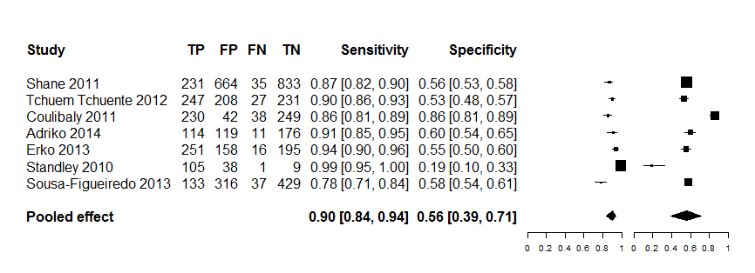

For POC-CCA, trace was considered as positive.

Kato-Katz consisted of single stool with duplicate slides (41.7mg of stool sample each).

Data points for two studies28, 31 were extracted from another study40 that reported primary data from a multi-country study in Africa.

Two of the studies21, 36 did not use POC-CCA cassettes but reagent strips that preceded the cassette formulation.

Fig. 2b. **Diagnostic accuracy of single POC-CCA versus Kato-Katz reference standard for the detection of *S. mansoni* infection from SROC curve**

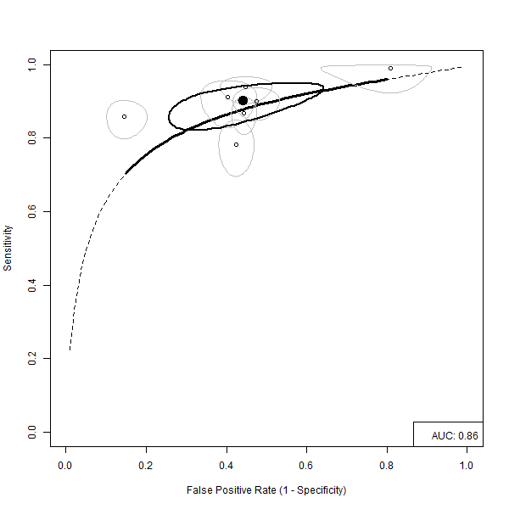

For POC-CCA, trace was considered as positive.

Kato-Katz consisted of single stool with duplicate slides (41.7mg of stool sample each).

Data points for two studies24, 38 were extracted from another study40 that reported primary data from a multi-country study in Africa.

Two studies21, 36 did not use POC-CCA cassettes but reagent strips that preceded the cassette formulation.

Fig. 2c. **Single POC-CCA test versus three Kato-Katz tests for the detection of *S. mansoni* infection**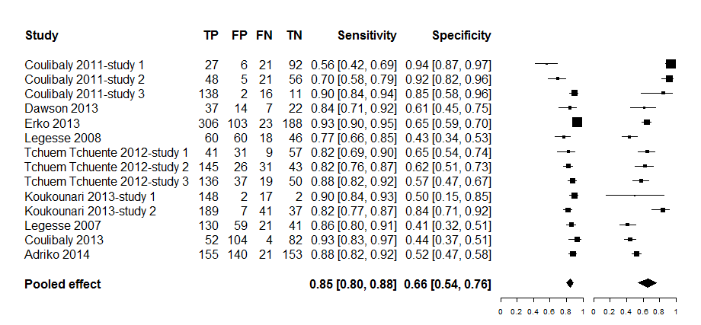

Kato-Katz consisted of three consecutive stools of duplicate slides each of 41.7 mg.

One of the studies23 used Kato-Katz from two consecutive stools.

While other two of the studies26,27 used an older version of POC-CCA reagent strips (manufactured by European Vertinary Laboratory, Woerden, Holland) and compared with combined Kato-Katz and Formal Ether concentration test as reference standard.

All other studies used POC-CCA cassette test (manufacturer: Rapid Medical Diagnostics, Pretoria, South Africa). Koukounari 2013-study 1 and Koukounari 2013-study 2 involved separate data for children (7-16 years) and adults (≥ 17 years) so we reported tem separately as data independent studies in the analysis.

Fig. 2d. **Three POC-CCA tests versus Kato-Katz from three consecutive stools for the detection of *S. mansoni* infection**

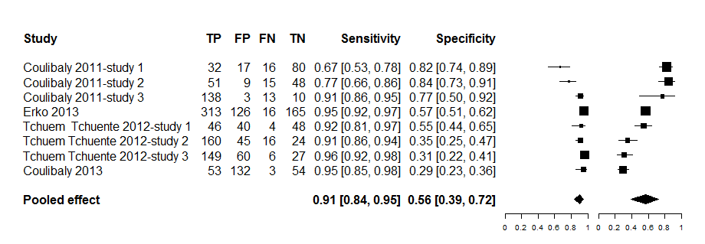

One study37 used duplicate instead of three POC-CCA cassette tests, the rest of the studies assessed three POC-CCA tests; the same study also used two consecutive stools for Kato-Katz tests, the rest of the studies used three consecutive stools.

For POC-CCA test, trace was considered as positive test.

Fig. 2e. **Assessment of diagnostic accuracy between single and multiple POC-CCA and single and multiple Kato-Katz tests for the diagnosis of *S. mansoni* infection**

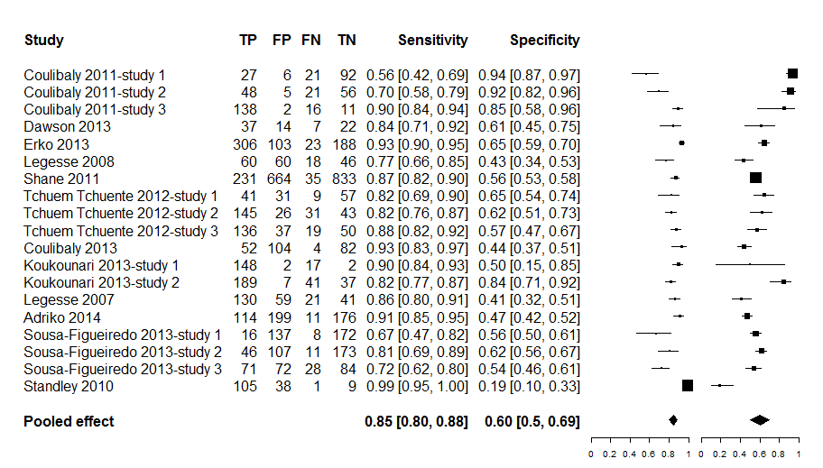

Studies included in this analysis had both index and reference tests examined in the same participants at the same time.

Where a study assessed single, two, or three POC-CCA, the results of the single POC-CCA was. Single POC-CCA test were chosen for the analysis from Erko 2013 and Tchuem Tchuente 2012 study1; Tchuem Tchuente 2012 study 2; Tchuem Tchuente 2012 study3.

For POC-CCA test, trace was considered as positive.

Where a study assessed single, two or three Kato-Katz, single Kato-Katz (duplicate 41.7 mg) was chosen as reference standard in conformity with what WHO recommends within the MDA/PC Strategy. Single Kato-Katz was chosen for the analysis from Erko 2013.

If different settings were involved in a study published as one article but reported results for the separate settings, the different settings were included as separate data points. Coulibaly 2011 was classified as Coulibaly 2011 -study 1; Coulibaly 2011 -study 2; Coulibaly 2011 -study 3 and Tchuem Tchuente 2012 as Tchuem Tchuente 2012 -study 1; Tchuem Tchuente 2012 -study 2; Tchuem Tchuente 2012 -study 3).

Children and adults data reported separately were considered as separate datapoints in this analysis (Koukounari 2013).

Fig. 3. **Performance of POC-CCA strips versus standard 10 mL urine filtration for the diagnosis of urinary schistosomiasis**

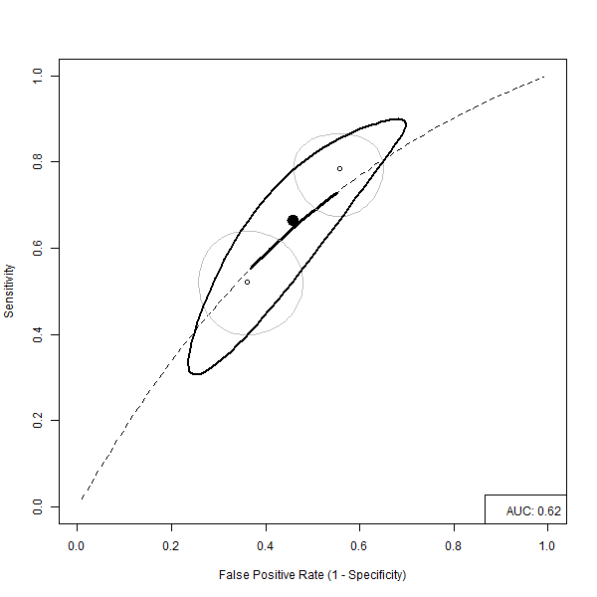

POC-CCA reagent strips study11 with trace counted as positive test.

Fig. 4. **LCBM showing Latent Classes of POC-CCA test**

